REMY’S
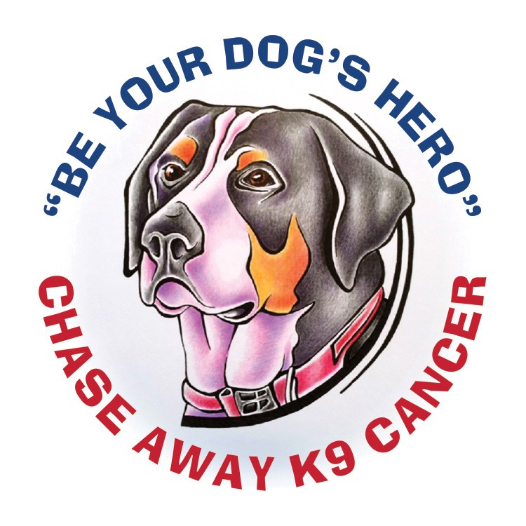
RUN: 5K FUN

RUN/WALK
SATURDAY SEPTEMBER 25th 2021 AT 10:30 AM
Hickory Grove Lake: Snow Bunting Lodge: 67423 250th St Colo Ia 50056

Race Information:
This is a fun, family race, fur babies included, to raise money for the Chase Away K9 Cancer foundation. In memory of our beloved Greater Swiss Mountain Dog, Remy, who we lost to bone cancer on June 16,2018. Race hosted by Heather’s Fur Babies. Food Trucks this year so bring cash Ally’s Sandwiches and wraps and Sweet & Savory LLC.
Registration and Packet Pick up Information:
There are 3 ways you can register for the race:
- You can register online at:
www.GetMeRegistered.com/RemysRun
- You can print off these sheets at furbabies4.com under forms and mail in with check to Heather’s Fur Babies at 24541 670th Ave Nevada, IA 50201.
- You can register day of. There will be a separate table for day of registration between 9-9:30am no shirt though.
In order to get a long sleeve t-shirt, you must register by September 1st. There will be no pre-race shirt pick up they will be handed out morning of the race.
Entry Fee: Registration
$25.00 per person children 12 and under are free no shirts for kids.
Online sign up has additional processing fee, but mail-in or day-of registrations will be just $25
Prizes:
This is a fun run so not timed, but we will award prizes to top 3 finishers. People and Dogs.

ALL PROCEEDS SPLIT BETWEEN CHASE AWAY K-9 CANCER AND ISU IRONDOG FOUNDATIONS.
ENTRY FORM
REMY’S RUN: 5K FUN RUN/WALK
Chase Away Canine Cancer
Name: ______________________________________ Number of dogs: ______________________________
Address: ____________________________________ Size of -tshirt S/M/L/XL/ XXL: ____________________
Please mail form with check payable to Heather’s Fur Babies to: 24541 670th Ave Nevada Ia. 50201 by September 1st 2021.
Waiver: In consideration of you accepting this entry, I, the participant, intending to be legally bound and herby waive or release any and all right and claims for damages or injuries that I may have against the event director, and all other agents assisting with the event, sponsors and their representatives and employees for any and all injuries to me or my personal property. This release includes all injuries and or damages suffered by me before, during or after the event. I recognize, intend and understand that this release is binding on my heirs, executors, administrators, or assignees.
I certify as a material condition to my being permitted to enter this race that I am physically fit and sufficiently trained for the completion of this event, walking or running 3.2 miles. By submitting this entry, I acknowledge (or parent or adult guardian for children under 18) having read and agree to the above waiver.
___________________________________________ ________________________________________
Signature of Participant Date
Emergency Contact Information:
Name: ____________________________________________________________________________________ Phone Number: ____________________________________________________________________________

